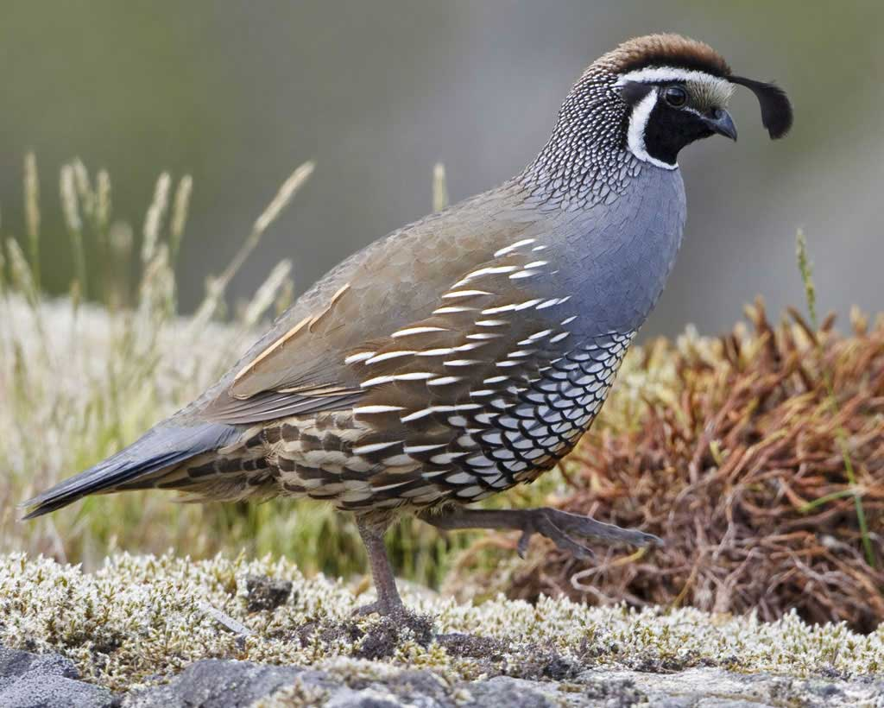

August 2, 2017

Dear Congressman DeSaulnier,

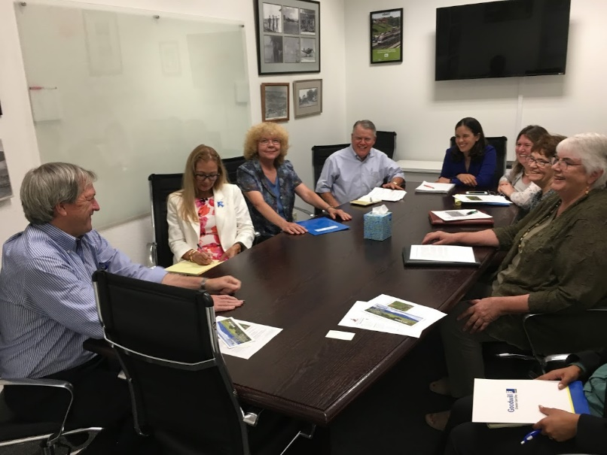
Thank you again for making the time to meet with us yesterday to discuss federal policy priorities of concern to Mt. Diablo Audubon Society. We enjoyed hearing your feedback on hearings and how we can take action to protect birds and habitat.

We were glad to hear of your support for a strong Endangered Species Act. We also really appreciated hearing your comparison of migratory birds as undocumented migrants!

We will work with Jessica to try to find a time for a bird walk in District 11, hopefully for this fall. We look forward to working with your office on environmental issues.

Sincerely,
Mt. Diablo Audubon Society
Rosalie Howarth Carol Pachl
Georgette Howington Ariana Rickard
Mike Mecham Heather Rosmarin
Nancy Wenninger

