August 2017

Federal Policy Priorities for Mount Diablo Audubon Society
Mission
Mount Diablo Audubon Society is committed to the sustainable balance of our community’s people, birds, other wildlife and habitat through conservation, education and advocacy.

Endangered Species Act
The Endangered Species Act has helped protect thousands of vulnerable species of plants and animals. We SUPPORT keeping these protections in place with funding to USFWS and NOAA.

- OPPOSE -- H.R. 717,
Would require review of the economic cost of adding a species to the list of endangered species or threatened species.
- OPPOSE -- H.R. 2603, Would exclude non- native species.
- OPPOSE -- H.R. 1274
- OPPOSE -- H.R. 3131

National Monuments, National Marine
Sanctuaries, offshore oil drilling

We OPPOSE any efforts to weaken these designations and approve new offshore oil drilling

Sage-grouse conservation
The Greater Sage-Grouse has declined precipitously due to widespread habitat destruction. Stakeholders developed a balanced conservation plan, but the Department of the Interior is considering weakening or eliminating these vital habitat protections.

• OPPOSE -- S. 273/HR 527

Neotropical Migratory Bird Conservation Act

We SUPPORT funding for Neotropical Migratory Bird Conservation Act – urge reauthorization and funding at $4.1 million.

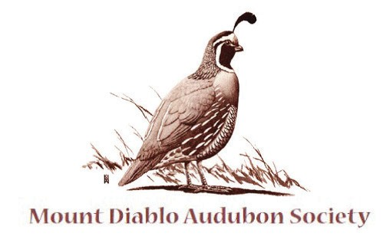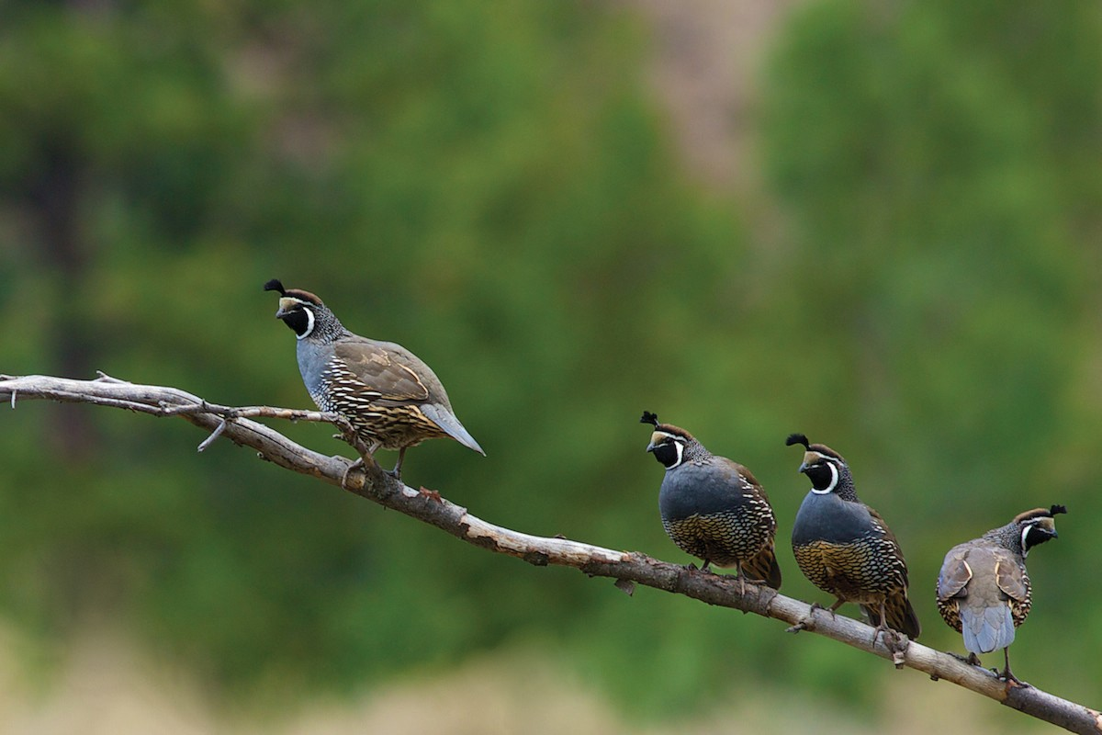 Mount Diablo Audubon Society
P.O. Box 53, Walnut Creek, CA 94597
Ariana Rickard, arickard@audubon.org, (415) 644-4602
www.diabloaudubon.com

