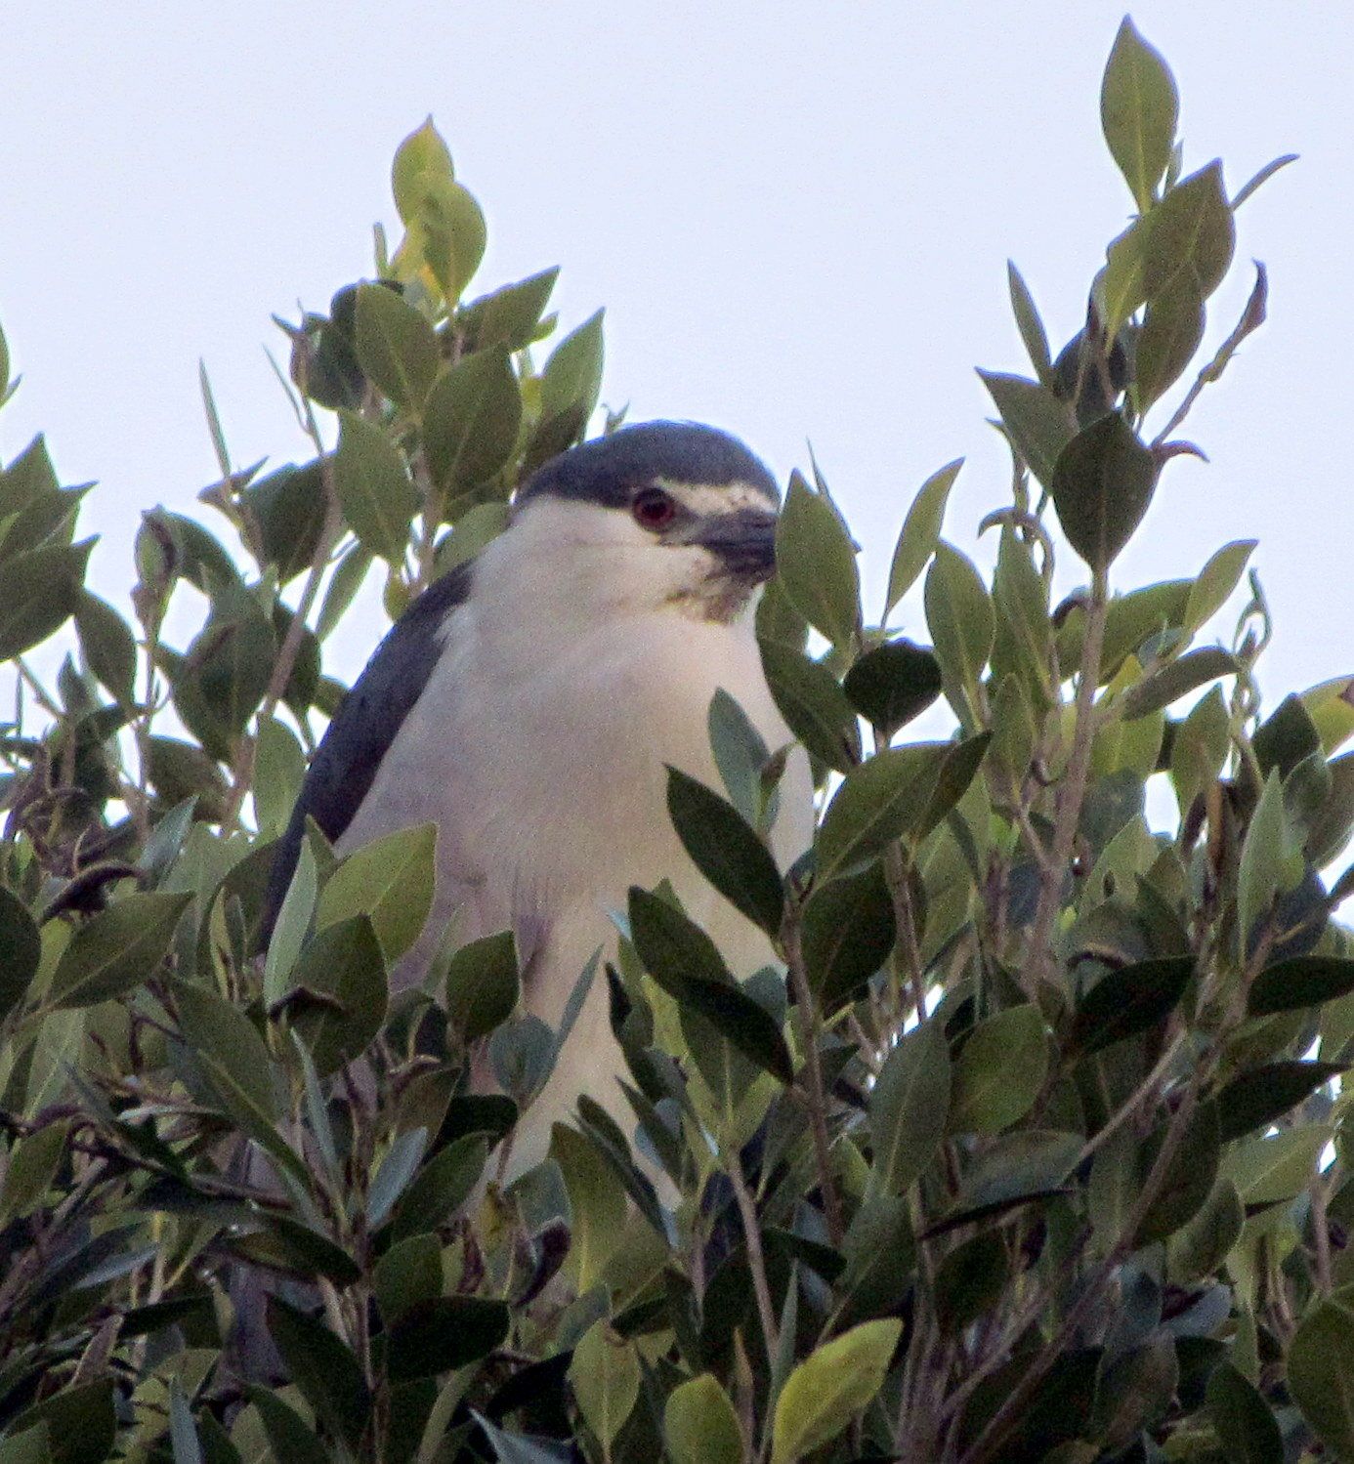

Black-crowned Night Heron in tree in Oakland
Black-crowned Night Heron in tree in Oakland

Dear Assembly Member Bonta,  We would like to thank your Assembly Fellow, Alma Barreras, for meeting with us last Thursday to discuss legislative issues of concern to Golden Gate Audubon Society and California Audubon members. We briefly highlighted some GGAS activities, including a docent program to rescue baby Black-crowned Night Herons that fall out of nests onto Oakland streets.  .  We asked Ms. Barreras to convey our appreciation for your past support and described several of the reasons we are asking you to support:  - SB 49, SB 50, and SB 51, the “Green Shield” legislation;  - SB 249 which addresses gaps in the regulation of Off-road Vehicles;  - the park and water bond bill, SB 5;  - and the Salton Sea legislation, SB 615.  We also urged her to encourage you to work with leadership and the Governor to find ways to extend the cap-and-trade program.  Gaylon Parsons, Alameda  Chis Winn, Oakland  Marjorie Powell, Alameda  cc. Alma Barreras | Dear Assembly Member Bonta,  We would like to thank your Assembly Fellow, Alma Barreras, for meeting with us last Thursday to discuss legislative issues of concern to Golden Gate Audubon Society and California Audubon members. We briefly highlighted some GGAS activities, including a docent program to rescue baby Black-crowned Night Herons that fall out of nests onto Oakland streets.  .  We asked Ms. Barreras to convey our appreciation for your past support and described several of the reasons we are asking you to support:  - SB 49, SB 50, and SB 51, the “Green Shield” legislation;  - SB 249 which addresses gaps in the regulation of Off-road Vehicles;  - the park and water bond bill, SB 5;  - and the Salton Sea legislation, SB 615.  We also urged her to encourage you to work with leadership and the Governor to find ways to extend the cap-and-trade program.  Gaylon Parsons, Alameda  Chis Winn, Oakland  Marjorie Powell, Alameda  cc. Alma Barreras

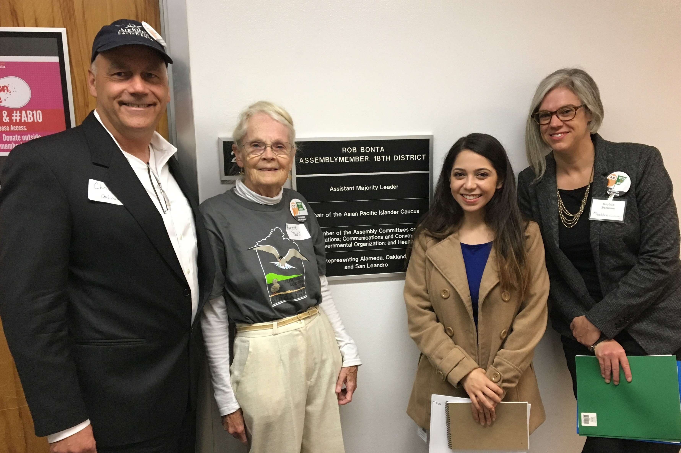

Created by Marjorie Powell

Created by Marjorie Powell

